**Components of Machine Learning**

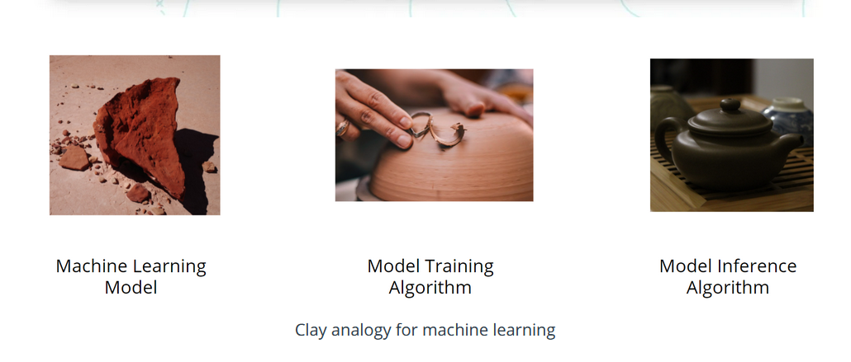

Nearly all tasks solved with machine learning involve three primary components:

* A machine learning model
* A model training algorithm
* A model inference algorithm

**Clay Analogy for Machine Learning**

You can understand the relationships between these components by imagining the stages of crafting a teapot from a lump of clay.

1. First, you start with a block of raw clay. At this stage, the clay can be molded into many different forms and be used to serve many different purposes. You decide to use this lump of clay to make a teapot.
2. So how do you create this teapot? You inspect and analyze the raw clay and decide how to change it to make it look more like the teapot you have in mind.
3. Next, you mold the clay to make it look more like the teapot that is your goal.

Congratulations! You've completed your teapot. You've inspected the materials, evaluated how to change them to reach your goal, and made the changes, and the teapot is now ready for your enjoyment.

**What are machine learning models?**

A machine learning model, like a piece of clay, can be molded into many different forms and serve many different purposes. A more technical definition would be that a machine learning model is a block of code or framework that can be modified to solve different but related problems based on the data provided.

**Important**

A model is an extremely generic program(or block of code), made specific by the data used to train it. It is used to solve different problems.

**Two simple examples**

**Example 1**

Imagine you own a snow cone cart, and you have some data about the average number of snow cones sold per day based on the high temperature. You want to better understand this relationship to make sure you have enough inventory on hand for those high sales days.

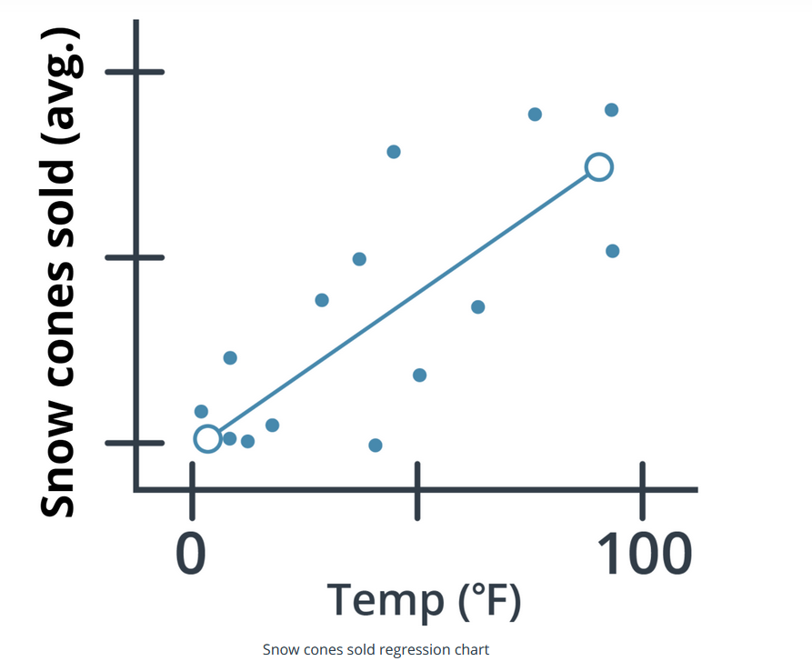

In the graph above, you can see one example of a model, a *linear regression model* (indicated by the solid line). You can see that, based on the data provided, the model predicts that as the high temperate for the day *increases* so do the average number of snow cones sold. Sweet!

**Example 2**

Let's look at a different example that uses the same *linear regression model*, but with different data and to answer completely different questions.

Imagine that you work in higher education and you want to better understand the relationship between the cost of enrollment and the number of students attending college. In this example, our model predicts that as the cost of tuition increases the number of people attending college is likely to decrease.

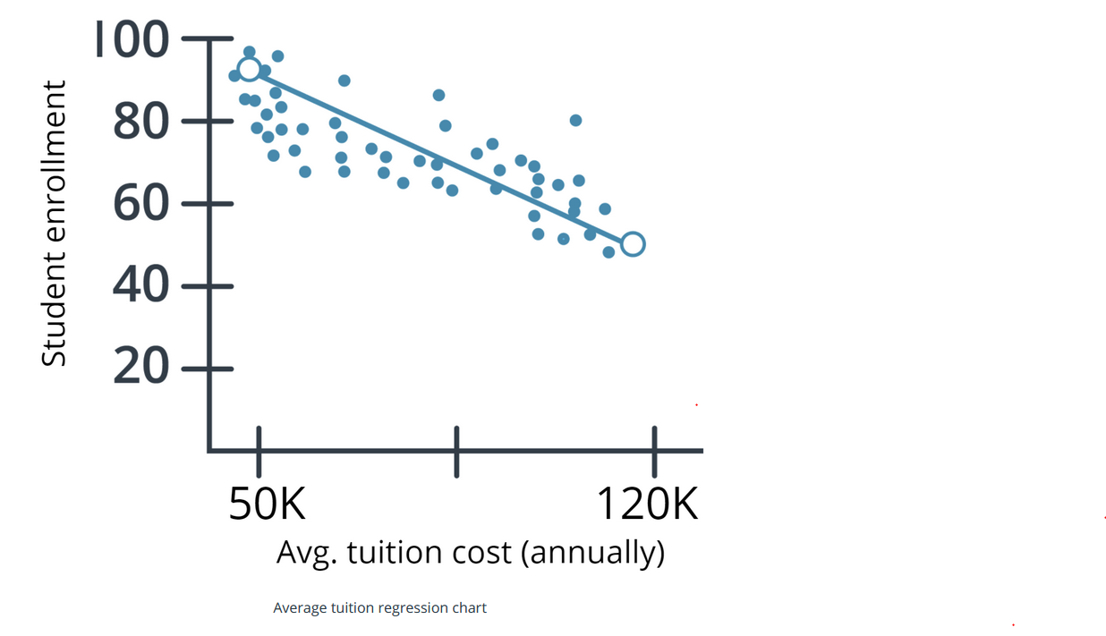

Using the same linear regression model (indicated by the solid line), you can see that the number of people attending college does go down as the cost increases.

Both examples showcase that a model is a generic program made specific by the data used to train it.

**Model Training**

**How are model training algorithms used to train a model?**

In the preceding section, we talked about two key pieces of information: a model and data. In this section, we show you how those two pieces of information are used to create a trained model. This process is called *model training*.

**Model training algorithms work through an interactive process**

Let's revisit our clay teapot analogy. We've gotten our piece of clay, and now we want to make a teapot. Let's look at the algorithm for molding clay and how it resembles a machine learning algorithm:

* **Think about the changes that need to be made.** The first thing you would do is inspect the raw clay and think about what changes can be made to make it look more like a teapot. Similarly, a model training algorithm uses the model to process data and then compares the results against some end goal, such as our clay teapot.
* **Make those changes**. Now, you mold the clay to make it look more like a teapot. Similarly, a model training algorithm gently nudges specific parts of the model in a direction that brings the model closer to achieving the goal.
* **Repeat.** By iterating over these steps over and over, you get closer and closer to what you want until you determine that you’re close enough that you can stop.

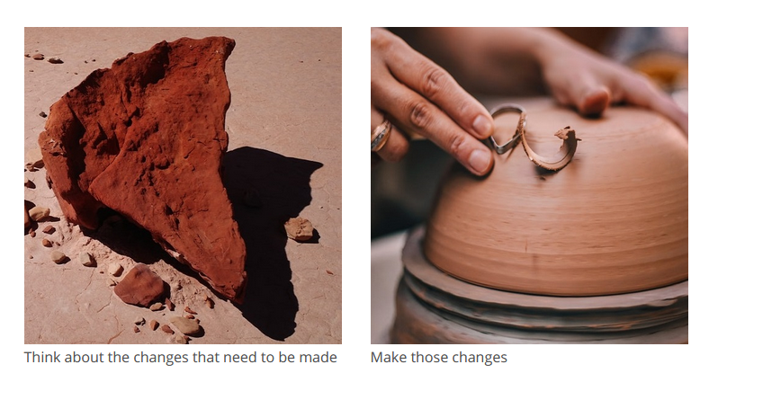

**Model Inference: Using Your Trained Model**

Now you have our completed teapot. You inspected the clay, evaluated the changes that needed to be made, and made them, and now the teapot is ready for you to use. Enjoy your tea!

*So what does this mean from a machine learning perspective?* We are ready to use the model inference algorithm to generate predictions using the trained model. This process is often referred to as **model inference.**

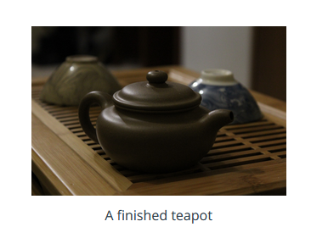

**Images**

* [Clay](https://images.unsplash.com/photo-1568374769301-2358f564f4db)
* [Clay hands](https://images.unsplash.com/photo-1596919184543-0b190d9837d7)
* [Teapot](https://images.unsplash.com/photo-1610304738695-b3ac687a57d0)

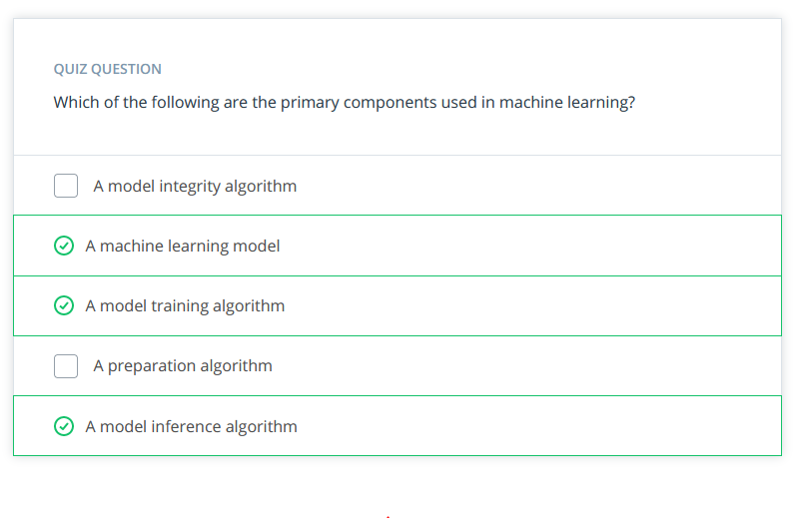

**Terminology**

A **model** is an extremely generic program, made specific by the data used to train it.

**Model training algorithms** work through an interactive process where the current model iteration is analyzed to determine what changes can be made to get closer to the goal. Those changes are made and the iteration continues until the model is evaluated to meet the goals.

**Model inference** is when the trained model is used to generate predictions.